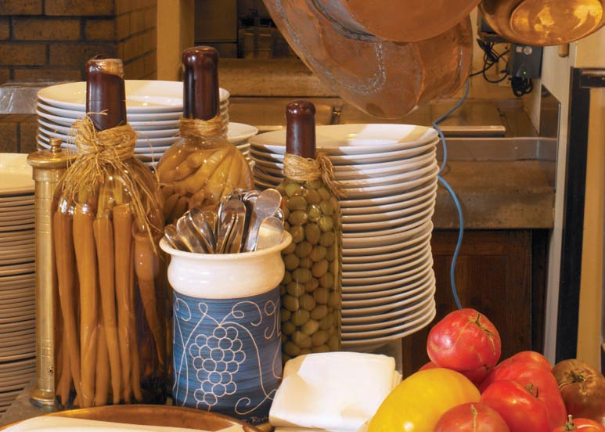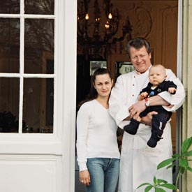

**Grilled Halibut with lavender flowers- (Main entree)**

**Light Mango pudding- (Dessert)**

**Friday Menu**

**Sauteed swiss chard with garlic & anise- (Starter)**

Kouzounas Kitchen

Footer. Footer. Footer. Footer. Footer. Footer. Footer. Footer. Footer.

Menu Item

$$$

Item description

Menu Item

$$$

Item description

Menu Item

$$$

Item description

Menu Item

Header

$$$

Item description

Menu Item

$$$

Item description

Menu Item

$$$

Menu Item

$$$

Item description

$$$

Item description

Menu Item

Header

Item description

Footer. Footer. Footer. Footer. Footer. Footer. Footer. Footer. Footer.

Item description

Menu Item

$$$

Item description

Menu Item

$$$

Item description

Menu Item

$$$

Item description

Menu Item

$$$

Item description

Menu Item

$$$

Item description

Menu Item

Header

$$$

$$$

Item description

Menu Item

$$$

Item description

Menu Item

$$$

Item description

Menu Item

$$$

Item description

Menu Item

Header

Aliquam lectus orci, adipiscing et, sodales ac, feugiat non, lacus. Ut dictum velit nec est. Quisque posuere, purus sit amet malesuada blandit, sapien sapien auctor arcu, sed pulvinar felis mi sollicitudin tortor. Maecenas volutpat, nisl et dignissim pharetra, urna lectus ultrices est, vel pretium pede turpis id velit.

Aliquam sagittis magna in felis egestas rutrum. Proin wisi libero, vestibulum eget, pulvinar nec, suscipit ut, mi. Integer in arcu ultricies leo dapibus ultricies. Sed rhoncus lobortis dolor. Suspendisse dolor. Mauris sapien velit, pulvinar non, rutrum non, consectetuer eget, metus. Morbi tincidunt lorem at urna. Etiam porta.